**Pie-in-the-Sky**

**IPL Match Bidding App**

**Pie-in-the-Sky is a mobile app** that is used for bidding for **IPL matches** legally. **Any registered user can bid for any of the IPL matches listed in it**. **New users or bidders need to register themselves** into the app by providing their mobile phone number, email id, and password. Admin will maintain the match roster and keep updating other details in the system.

The **app shows the match details** which include the playing team, the venue of the match, and the current standing of the teams on the points table. It will display the winner at the end of the match and update the team standings in the tournament and bidder points table. System will send updates to the bidders whenever required. It will also generate the bidders' leader board.

App functionalities:

#### Predict Winner

The app **allows the user to predict the winner of the match** before the toss happens for the match on which the user is predicting. This is dynamic as the matches can have a different start time. Start time will also be influenced by disruptions like rains and other unforeseen circumstances. **Users will not be able to see what others have predicted. Users** **can change the team bids only till the toss happens**. Once the **toss happens everything freezes** for that match.

#### Point System

For **every win, users get points**. There are no negative points, meaning if the user loses the bid, he or she does not lose his/her points. The Point system is very dynamic.

At the start of the tournament when every team is at zero points, every user who wins the prediction wins 2 points.

If the difference in **the points between two teams playing, is <= 6,** but > 0, then the person who predicts:

* Team with higher points will win, gets 2 points
* Team with lower points will win, gets 3 points

If the difference in the points between two teams playing is > 6, then the person who predicts:

* Team with higher points will win, gets 2 points
* Team with lower points will win, gets 5 points

#### Leader board

At every time the user will be able to see his/her points and his/her position in the overall user standings. He/she will also be able to see the top 3 leader positions

A bidder can do the following things using this app:

* can see all the match schedules (teams, date & time of the match, location).
* bid on a team for a match before the start of the match
* can predict the match winner only till its toss occurs (Note that match start time might change due to weather conditions)
* can bid for any number of matches
* after bidding on a team, (s)he would be able to change his/her team before the match starts
* bidding cannot be changed once the respective match starts
* can cancel the bid on a match; will not lose any points
* At any time, the bidder will be able to see his/her points and his/her position in the overall bidder standings.
* can see top 3 leader positions
* can see team standings anytime (i.e. their points tally)
* cannot see any details of other bidders

Admin can do following activities:

* manage tournament (tournament id, duration, description)
* manage teams (description of players and team)
* schedule and reschedule matches. Each team will play only once with the remaining teams
* edit details of match and stadium
* update match statistics (date and match result of all the earlier matches)
* declare the result of the match along with their scores
* declare winner and loser along with their points
* update team statistics (team and player performance)
* update overview at the end of the match
* view all the bidders bidding on a particular team and the %age of users supporting a team

**ER Diagram**

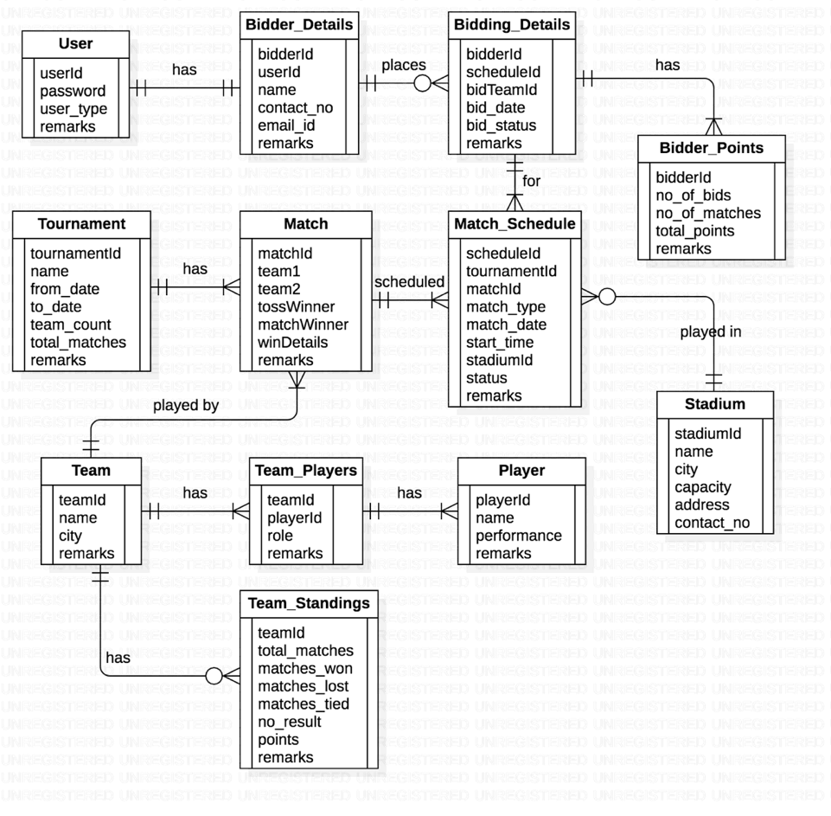

**List of Tables**

1. **Table: IPL_User**

|  |  |  |
| --- | --- | --- |
| Column name | Data type | Comments |
| **UserId** | VARCHAR | Primary Key - Unique id for the User |
| Password | VARCHAR | Password to for the User |
| User_type | VARCHAR | Admin or Bidder |
| Remarks | VARCHAR | Only null values |

1. **Table: IPL_Stadium**

| Column name | Data type | Comments |
| --- | --- | --- |
| **StadiumId** | NUMBER | Primary key - Unique ID’s for stadium |
| Stadium_name | VARCHAR | Unique, Not null - Name of the Stadium |
| City | VARCHAR | City name of the Stadium present |
| Capacity | NUMBER | Capacity of the stadium |
| Address | VARCHAR | Address of the stadium |
| Contact_no | NUMBER | Contact number of the stadium |

1. **Table: IPL_Team**

|  |  |  |
| --- | --- | --- |
| Column name | Data type | Comments |
| **TeamId** | NUMBER | Primary key - Unique team id for all the teams |
| Team_name | VARCHAR | Unique, Not null - Team name for all the teams |
| Team_city | VARCHAR | Origin city of the team |
| Remarks | VARCHAR | Short form of the team names |

1. **Table: IPL_Player**

|  |  |  |
| --- | --- | --- |
| Column name | Data type | Comments |
| **PlayerId** | NUMBER | Primary key |
| Player_name | VARCHAR | Unique, Not null |
| Performance_dtls | VARCHAR | Performance details |
| Remarks | VARCHAR | Remarks like a top performer or second best performer |

1. **Table: IPL_Team_players**

|  |  |  |
| --- | --- | --- |
| Column name | Data type | Comments |
| **TeamId** | NUMBER | Composite Primary key |
| **PlayerId** | NUMBER | Composite Primary key |
| Player_role | VARCHAR | Captain, Batsman, Bowler, WK, etc. |
| Remarks | VARCHAR | Team names that he has been played for. |

1. **Table: IPL_Tournament**

| Column name | Data type | Comments |
| --- | --- | --- |
| **TournamentId** | NUMBER | Primary key |
| Tournament_name | VARCHAR | Not null |
| From_date | DATE | Tournament starting date |
| To_date | DATE | Tournament ending date |
| Team_count | NUMBER | Total team count of the seasons |
| Total_matches | NUMBER | Total matches the team had played for each season's |
| Remarks | VARCHAR | Champions teams name of the seasons |

1. **Table: IPL_Match**

| Column name | Data type | Comments |
| --- | --- | --- |
| **MatchId** | NUMBER | Primary key |
| TeamId1 | NUMBER | FK from Team table. Not null |
| TeamId2 | NUMBER | FK from Team table. Not null |
| TossWinner | NUMBER | Team no. 1 or 2 |
| MatchWinner | NUMBER | Team no. 1 or 2 |
| WinDetails | VARCHAR | Team 1 or 2 Won by XX runs or X wickets, Match tied. |
| Remarks | VARCHAR | E.g. Match canceled due to rain. |

1. **Table: IPL_Match_Schedule**

| Column name | Data type | Comments |
| --- | --- | --- |
| **ScheduleId** | NUMBER | Primary key |
| TournamentId | NUMBER | FK from Tournament table. |
| MatchId | NUMBER | FK from Match table. |
| Match_type | VARCHAR | League, Knock out, Final, etc. |
| Match_date | DATE | This date should be within the from and to dates of the tournament. |
| Start_time | TIME |  |
| StadiumId | NUMBER | FK from Stadium table |
| Status | VARCHAR | Scheduled, Completed, Cancelled, etc. |
| Remarks | VARCHAR | Reasons for the march cancellation. |

1. **Table: IPL_Bidder_Details**

| Column name | Data type | Comments |
| --- | --- | --- |
| **BidderId** | NUMBER | Primary key |
| UserId | NUMBER | FK from User table. |
| Bidder_name | VARCHAR | Not null |
| Contact_no | NUMBER | Not null |
| Emailid | VARCHAR | Email id of the bidders' |
| Remarks | VARCHAR | Null values |

1. **Table: IPL_Bidding_Details**

| Column name | Data type | Comments |
| --- | --- | --- |
| **BidderId** | NUMBER | FK from Bidder table. Composite Primary key |
| **ScheduleId\*** | VARCHAR | FK from Match_Schedule table. Composite Primary key. |
| **BidTeam** | NUMBER | One of the team-ids of the match (1 or 2). Composite primary key. |
| **BidDate** | DATETIME | Exact date & time of placing the bid. Update this column if a bidder re-bids on the same team for the same match. Composite Primary key. |
| BidStatus | VARCHAR | Bid, Cancelled, Won, Lost |

* FK from Match_Schedule to bid for only matches that are ‘scheduled’.

1. **Table: IPL_Bidder_Points**

| Column name | Data type | Comments |
| --- | --- | --- |
| **BidderId** | NUMBER | FK from Bidder table. Primary key |
| TournamentId | NUMBER | FK from Tournament table. |
| No_of_bids | NUMBER | Total no. of bids placed by a bidder. Updated after completion of the match on which s/he placed the bid. |
| No_of_matches | NUMBER | Total no. of matches on which s/he placed the bid. Updated as above. |
| Total_points | NUMBER | Not null. Default 0 |

1. **Table: IPL_Team_Standings**

| Column name | Data type | Comments |
| --- | --- | --- |
| **TeamId** | NUMBER | FK from Team table. Primary key |
| TournamentId | NUMBER | FK from Tournament table. |
| Matches_played | NUMBER | Not null. Default 0 - Number of matches played |
| Matches_won | NUMBER | Not null. Default 0 - Number of matches won |
| Matches_lost | NUMBER | Not null. Default 0 - Number of matches lost |
| Matches_tied | NUMBER | Default 0 - Number of matches tied |
| No_result | NUMBER | Default 0 - Number of matches that have no results |
| Points | NUMBER | Not null. Default 0 - Total points of the team |
| Remarks | VARCHAR | mentioned champions |

**Instructions:**

1. Create these tables in the database by running the database script provided
2. The script also has statements to insert appropriate data into all of these tables
3. Test the successful execution of the script by selecting some rows from a few tables
4. Clearly understand the structure of each table and relationships among them
5. Insert/update appropriate rows into relevant tables if you need to get more rows in the output to verify your answers

**Problem Statement:**

The problem statement is to use the SQL queries to find the various insight from the above-given data. And also write your insights based on the results that you will get from the queries which you will be using.

**Example:**

**Let’s say You have written a complex query that showed you the results as “The XXX team won 8 matches out of 10 matches in XXX Stadium” and also it showed you that the majority of the teams that won the matches, won the toss as well and had chosen the fielding first.**

**Therefore, Your insight would be:**

**The Stadium must be a fielding pitch, which means that it favor’s the bowling because of various reasons, so the chasing team could control the opponent team with their bowling. Hence the teams that had won the toss and chosen the fielding, It is more likely to win the matches as well.**

**Few Questions have been provided to solve, Try to frame more questions if required.**

**Questions – Write SQL queries to get data for the following requirements:**

1. Show the percentage of wins of each bidder in the order of highest to lowest percentage.
2. Display the number of matches conducted at each stadium with the stadium name and city.
3. In a given stadium, what is the percentage of wins by a team which has won the toss?
4. Show the total bids along with the bid team and team name.
5. Show the team id who won the match as per the win details.
6. Display total matches played, total matches won and total matches lost by the team along with its team name.
7. Display the bowlers for the Mumbai Indians team.
8. How many all-rounders are there in each team, Display the teams with more than 4

all-rounders in descending order.

1. Write a query to get the total bidders points for each bidding status of those bidders who bid on CSK when it won the match in M. Chinnaswamy Stadium bidding year-wise.

Note the total bidders’ points in descending order and the year is bidding year.

Display columns: bidding status, bid date as year, total bidder’s points

1. Extract the Bowlers and All Rounders those are in the 5 highest number of wickets.

Note

1. use the performance_dtls column from ipl_player to get the total number of wickets

2. Do not use the limit method because it might not give appropriate results when players have the same number of wickets

1. Do not use joins in any cases.
2. Display the following columns teamn_name, player_name, and player_role.
3. show the percentage of toss wins of each bidder and display the results in descending order based on the percentage
4. find the IPL season which has min duration and max duration.

Output columns should be like the below:

Tournment_ID, Tourment_name, Duration column, Duration

1. Write a query to display to calculate the total points month-wise for the 2017 bid year. sort the results based on total points in descending order and month-wise in ascending order.

Note: Display the following columns:

1. Bidder ID, 2. Bidder Name, 3. bid date as Year, 4. bid date as Month, 5. Total points

Only use joins for the above query queries.

1. Write a query for the above question using sub queries by having the same constraints as the above question.
2. Write a query to get the top 3 and bottom 3 bidders based on the total bidding points for the 2018 bidding year.

Output columns should be:

like:

Bidder Id, Ranks (optional), Total points, Highest_3_Bidders --> columns contains name of bidder, Lowest_3_Bidders --> columns contains name of bidder;

1. Create two tables called Student_details and Student_details_backup.

|  |  |
| --- | --- |
| Table 1: Attributes | Table 2: Attributes |
| Student id, Student name, mail id, mobile no. | Student id, student name, mail id, mobile no. |

Feel free to add more columns the above one is just an example schema.

Assume you are working in an Ed-tech company namely Great Learning where you will be inserting and modifying the details of the students in the Student details table. Every time the students changed their details like mobile number, You need to update their details in the student details table. Here is one thing you should ensure whenever the new students' details come , you should also store them in the Student backup table so that if you modify the details in the student details table, you will be having the old details safely.

You need not insert the records separately into both tables rather Create a trigger in such a way that It should insert the details into the Student back table when you inserted the student details into the student table automatically.